*Florida International University*

*School of Computing and Information Sciences*

Software Engineering Focus

Feature Document

User Story ID <0005>

**Name:** Parker

**Team Member(s):** Parker Scott, Jose Maldonado

**Project: Learning with Augmented Reality 4.0**

**Product Owner(s)**: Ms. Vassigh

**Mentor(s)**: -

**Instructor**: Masoud Sadjadi

**User Story Name:**

* Description: **As a** User **I would like** to be able to target elements on my UI **so that** I can interact with UI elements in the map at places.

Acceptance Criteria

* No errors when compiling our current product in Unity
* UI element that flips around when you view the UI element

**Use Case**

* Name:
* Actor:
* Preconditions:
* Description <Flow of events>:

**Use Case Diagram <**you can use draw.io**>**

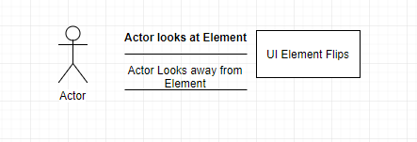

**Sequence Diagram**

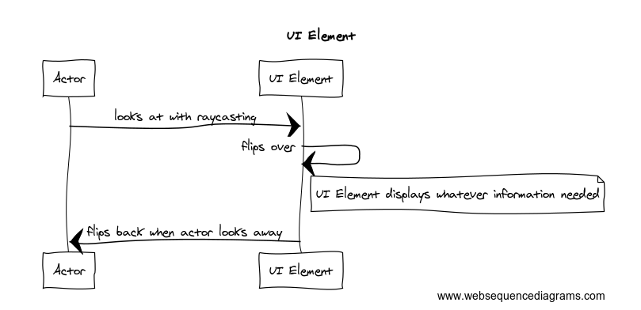

**Class Diagram**

**Unit Test**

* Test case ID: Not Tested
* Description/Summary of Test:
* Pre-condition:
* Expected Results:
* Actual Result:
* Status (Fail/Pass):

**Integration Test**

**Visual User Guide** <like one or two screenshots of the feature. For the hardware project, a photo of device is required>

